I. Introduction and Literature Review
Introduction
This project addresses the challenge of selecting effective fitness routines by integrating Model-Based Collaborative Filtering with Time Series Forecasting. We employed a Matrix Factorization approach—treating workout programs as "users"—to uncover latent stylistic patterns for personalized recommendations beyond simple keyword matching. Working in tandem with this, we made an autoregressive model to predict a persons bodyweight over a period of time with an exogenous input of a persons time spent exercising. This dual-method framework empowers users to not only discover stylistically relevant programs but also anticipate their potential performance outcomes.

Collaborative filtering for workout recommendation
Collaborative filtering is a decent fit for our recommendation system because users repeatedly perform exercise and leaving an exercise history that the system can learn from. When logging workout history, feedback is usually implicit as such ‘performed’, ‘skipped’, or ‘repeated’, rather than a specific number-based ratings, so ranking metrics like Precision@k or NDCG@k are more appropriate in this case. Surveys of sports recommender systems report that classic CF (user–user, item–item) and matrix factorization are common and effective, especially when combined with simple domain signals such as equipment and goals. These systems also emphasizes on context to boost performance, which is related to the user input part of our project. (Felfernig et al. 2024).
Adding body-part focus and explanations
Users often ask for workouts that target specific muscle groups. A recent paper mentioned and proposed knowledge-graph–enhanced exercise recommendation (KG4EER) that links exercises to muscles and goals to guide recommendations and provide human-readable explanations (for example, “recommended because it trains the posterior chain”). Even if we implement only classic CF for the course, we can adopt the idea: tag each exercise with its muscle groups, pre-filter to the requested body parts, and re-rank by CF score multiplied by muscle coverage. This improves relevance and lets us show rationales in the UI (Guan et al. 2025).
Time Series Modeling for Weight Projections
With obesity rates on the rise, Elina Helander et. al. aimed to answer how tim series modeling can be applied to the long term self-monitoring of body weight. Using autoregressive models, could meaningful insights show us patterns in behavior and insights into weight loss over time. From 2 participants tracked from 2005 to 2008 using self reported recorded daily weights. Cyclical fluctuations were found both on weekly and monthly scales. Weight was reflective of seasons, which can be explained by vacations and increased sociability in summer compared to more isolated winters. On a weekly basis, weight from weekend behaviors seemed to be reflected early on in the week, with it typically dissipating by the end of the next week (Elina Helander et. al. 2015). These patterns will be personal for each individual and not reflective of a population, but these findings to demonstrate the strong presence of daily weight fluctuations based on personal patterns.
Our Adaptations
Based on research from Elina Helander et. al. daily weights are inconsistent, with fluctuation that happens based on factors like diet, hydration, and bodily functions. Weight changes over time and actual progress may be hard to track. The goal of the study by Elina Elander et. al. was to reveal the prevalence of these factors and demonstrate cyclical patterns and trends in weight fluctuation (Elina Helander et. al. 2015). Our project looks to instead use similar time series methods to do the opposite and show users long term progress, with glimpses into the future to more accurately help people meet fitness goals. Mirroring their methodology, we can change the target to instead show users their current projections to provide more realistic timelines for weight loss and allow users to act proactively to adjust their routine accordingly. By factoring in calories burned each day, an added detail can improve model performance and create our desired outcome of a model reflecting a users trajectory over N months, or any timeline that fits user goals.
References
Felfernig, Alexander, Selma Polat-Erdeniz, Clemens Uran, et al. 2024. “Sports Recommender Systems: Overview and Research Directions.” Journal of Intelligent Information Systems 62: 1125–1164. https://doi.org/10.1007/s10844-024-00857-w
Guan, Qifan, Junjie Chen, Xian Ren, and Chao Zhang. 2025. “Explainable Exercise Recommendation with Knowledge Graph.” Neural Networks. https://doi.org/10.1016/j.neunet.2024.106954
Helander, E., Pavel, M., Jimison, H., & Korhonen, I. (2015). Time-series modeling of long-term weight self-monitoring data. 2015 37th Annual International Conference of the IEEE Engineering in Medicine and Biology Society (EMBC), 1616–1620. https://doi.org/10.1109/embc.2015.7318684

II. ML Methodology and Data Collection
Collaborative filtering
Data Sources: We utilized two Kaggle datasets: `gym-exercise-data` (containing metadata for individual exercises like body part, equipment, and rating) and `fitness-and-workout-dataset` (containing workout program and its metadata like description, time, and experience level).
How data were curated: Since there was no pre-existing link between the workout programs and the exercises, we developed a rule-based mapping algorithm in `data_preprocessing.ipynb` to synthesize these interactions:
1. Body Part Inference: We implemented a regex-based keyword extraction to infer target body parts (for example, ‘bench press’ will be mapped with ‘chest’ since the major muscle trained from bench press is chest) from the unstructured text titles and descriptions of the workout programs.
2. Compatibility Mapping: We created a dense interaction matrix by linking programs to exercises based on three compatibility criteria:
- Body Part Match: The exercise targets the same body part inferred for the program.
- Level Compatibility: The exercise difficulty (Beginner/Intermediate/Expert) aligns with the program's intended experience level.
- Equipment Compatibility: The exercise requires equipment available in the program's setting (for example ‘At Home’ will be mapped with ‘'Body Only', 'Bands', 'None', 'Exercise Ball', 'Foam Roll', 'Dumbbell', since we assume that these equipments are accessible at home)
3. Filtering: We removed mappings where exercises lacked a quality rating, also removed mappings where programs is not mapped with any specific body parts, resulting in a final `program_exercise.csv` dataset that serves as the ground data for our model, which contains the following features: ['program_id', 'program_title', 'program_description', 'program_goal', 'program_level', 'program_time_minutes', 'program_equipment','program_bodyparts', 'exercise_id', 'exercise_title', 'exercise_bodypart', 'exercise_equipment', 'exercise_level', 'exercise_rating']

Time Series
Data Sources:
For our Time series data, we chose to go with a study from Simula Research Laboratory where 16 users were tracked over a 5 month period. Many issues with other datasets surrounded missing data, small dataset size, isolated sample populations, and short recording lengths. This dataset solved each of those issues. The data far exceeded the majority of Kaggle datasets in terms of cleanliness. It lasted over 5 months with 16 participants, providing a gold mine of data. The target data in this set was participants daily bodyweights and their daily exercise level.
How data were curated:
Due to the structure of the data, many different files needed to be merged together to create a usable dataset. Using python, the datasets were merged into one and a usable dataset to train our time series on was created. For other preparation steps, dates were changed from strings to dates, interpolation was performed linearly, and a lag feature was created to incorporate yesterday’s weight into our time series model

ML Methods Overview
ML Method 1: Model-Based Collaborative Filtering (Matrix Factorization)
We implemented a custom Matrix Factorization system. While standard Collaborative Filtering (CF) typically uses a User-Item matrix, our approach adapts this structure by treating Programs as "Users" and Exercises as "Items".
Mathematical Formula: We constructed an interaction matrix R of size N(programs) x M(exercises). We decomposed this matrix into two lower-rank latent factor matrices, P (Program Factors, size N x K) and Q (Exercise Factors, size M x K), such that R is approximately equal to P x Q^T.
Optimization: We used Gradient Descent with L2 regularization to minimize the reconstruction error. This allows the model to learn K=15 latent features (For example, equipment constraint and experience level constraint factor) that explain why certain exercises appear in certain programs.
Scoring: Recommendations are generated by projecting a user's "Liked Exercises" vector u against the reconstructed matrix R^hat = P x Q^T. The score for program p is calculated as the dot product of the reconstructed program vector and the user vector. This effectively recommends programs that are conceptually similar to the user's preferences, even if they do not contain the exact same exercises. Additionally, we apply a strict penalty to programs containing exercises explicitly 'Disliked' by the user. This effectively recommends programs that are conceptually similar to the user's preferences, even if they do not contain the exact same exercises.
Time Series Model
Based on what we had learned about time series models, it made the most sense to create an Autoregressive Model with Exogenous Regressors (ARX(1)). Because it is not possible for humans to change large amounts of weight overnight, weight is a reliably steady day in and day out. We wanted to lean into the reliability of weight and use that as an anchor to show the slow but consistent progress exercise has over time The ARX(1) model was mentioned in lecture as an extension of AR(1) models that allows for additional variables beyond the lagged weight. By using the ARX(1) model, active minutes can be added to help predict progress over time from exercise with reliable insight provided by bodyweight.
The mathematics behind the ARX(1) model are very similar to the AR(1) model. The only difference in the formula is the addition of of w₂ x_{t – 1} to the equation. The original formula that would be used for an AR(1) model here would be y_{t} = w₀ + w₁ y_{t-1} + ε _{t}. With w₂ being the weight burned per minute of exercise and x_{t – 1} being the minutes of exercise. y_{t-1} would still be the lagged weight and w₁ would still be our anchor for the aggressive weight. The final formula is y_{t} = w₀ + w_₁ y_{t-1} + w₂ x_{t – 1} + ε _{t}

III. ML Results and Interpretation
Results – Collaborative filtering
Matrix Factorization model successfully learned latent structures within the workout data.
Convergence: The manual Gradient Descent implementation converged stably with a learning rate of alpha=0.0001 over 200 iterations.
Qualitative Performance: The model demonstrated the ability to generalize beyond exact keyword matching. For example, when a user selected "Bench Press" (a Chest/Strength exercise), the model recommended programs like "1 PowerLift Per Day" and "12 Week Transformation". Crucially, these programs were highly relevant even if they contained variations of the exercise (e.g., "Dumbbell Press") rather than the exact input, proving that the latent factors (P and Q) successfully captured the underlying concept of "Upper Body Strength" rather than just memorizing exercise names.
Sparsity Handling: The reconstruction step successfully filled in the sparse interaction matrix. Programs that originally had 0 ratings for specific exercises were assigned non-zero predicted scores, allowing the system to recommend "hidden gems"—programs that are stylistically perfect for the user but might have been missed by a simple content filter.
Image sample of the UI with specified input:
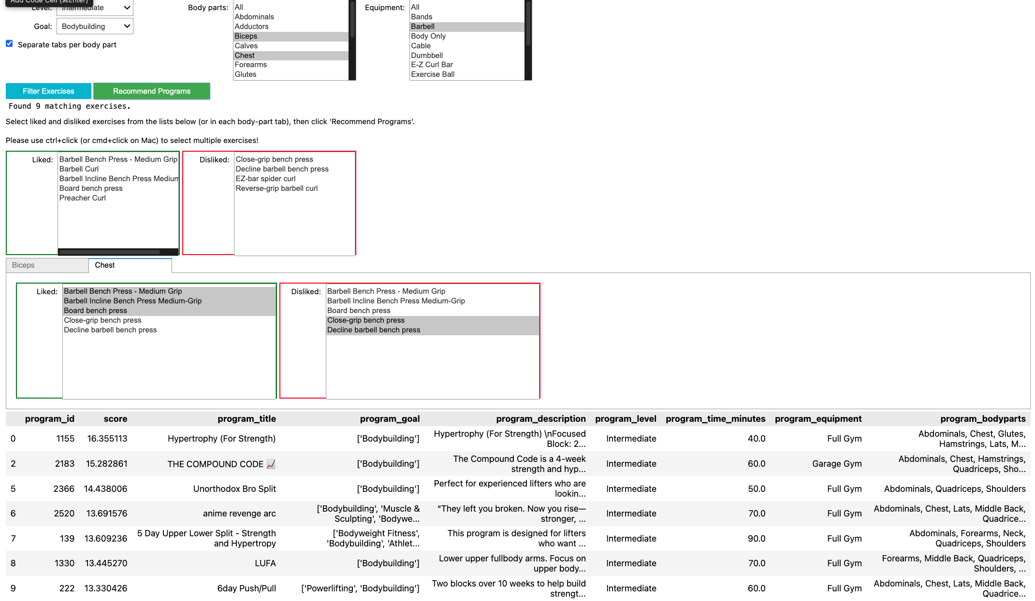

Results – Time Series Prediction
Human bodyweight is constantly fluctuating, with what we consume as well as our bodily functions, there is a lot of noise when looking at weights that are still considered stable. Despite basic human biology, we were able to get our RMSE down to around three quarters of a pound, 0.3486 kg precisely. The RMSE being this low in a situation as fluid as weight gives us confidence in the daily weigh estimations. It is estimated that 0.000184 kg is lost per minute of exercise based on the collected data.
When looking at residuals over time, there is a relatively small error, however variance increases around 350-400. Realistically, this spike in this time frame may come from holidays, vacations, or illnesses. In the future, incorporating these factors into the calendar year may help improve performance, however holidays falling around the same time every year may help isolate this issue. The spike in the ACF plot at lag-1 is reflective of the human body performing homeostasis, as it tries to return to baseline.
The model captures the immediate physiological impact of exercise. The sawtooth pattern created by the models plots is representative of workout schedule, clearly capturing the weight lost on sessions and the recovery of the body on rest days.
Although the predictions point to minimal weight loss through exercise, our model does not account for each body’s individual metabolisms and diet. What you see is forecasted progress based on no changes in diet and may not be in tune to your own metabolic rate. However, there is clear evidence that even without diet changes, weight can be lost through exercise alone.
Based on testing a 90kg person on a 5-day-per-week training schedule with 90-minute workout sessions each, it is expected that 0.04kg will be lost over 30 days. While it doesn’t move the needle very far, with the addition of diet and over a longer period of time, a much more drastic change will be noticed. Weight itself is also not the only metric of progress, as despite the small changes on the scale, body fat percentages and muscle mass may be improving as well.

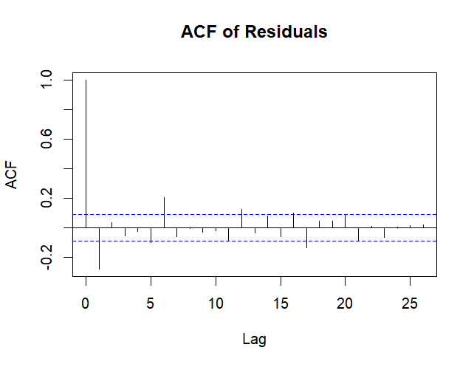
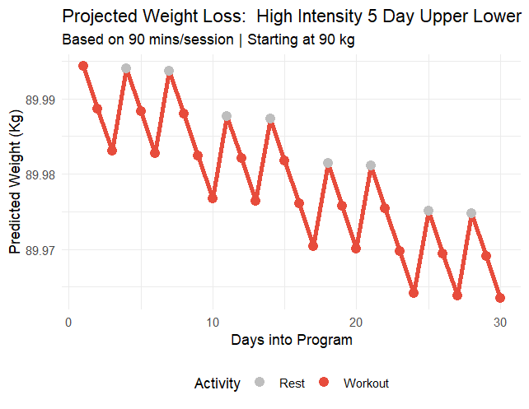

IV. Conclusions and Future Work
Summary of Findings
Callaborative filtering: Our study demonstrates that Matrix Factorization can be an effective technique for workout program recommendation, even in the absence of user interaction history. By inverting the standard Collaborative Filtering(treating Programs as Users), we extracted latent stylistic features from workout data. The model moved beyond rigid filtering to provide recommendations that capture the intent of a user's workout preferences.
Time Series prediction:
Through time series analysis we were able to discover the weight loss coefficient, for every minute you work out, you can expect to lose 0.2 grams of weight when checking the scale the next day. Our model is conservative, as it does not account for diet or personalized metabolic rates. Although the weight loss is small, over time the minutes add up, and paired with a heathy diet the scale will continue to move. And with an RMSE of 0.35 kg, you can be confident that over time results will prove true and weight loss will be noticed. These finding aligns with established physiological benchmarks for weight loss from exercise alone, validating the model's realism.
Assumptions and Appropriateness
Collaborative filtering
Assumption: The core assumption of Matrix Factorization is that "users" (programs) who agree on some items (exercises) will agree on others. This held true; programs targeting "Legs" consistently contained clusters of related leg exercises, validating the use of latent factors.
Data Appropriateness: The use of intrinsic exercise ratings as a proxy for "user ratings" was a necessary heuristic. While appropriate for a cold-start system, it assumes that a high-quality exercise is equally valuable in all compatible programs, which may not always be true (e.g., a high-rated cardio move might be "noise" in a powerlifting program).

Times Series
Assumption:
Although metabolism is known to not be linear, the linearity of the ARX(1) model does seem to be sufficient due to the low slope. The model would only struggle due to its linearity once unheard of human weights are used
When looking at weight loss, time seems to be a clear important factor, so using time series in our analysis seemed the most logical. When limited by the AR(1) model due to its inability to incorporate participants active minutes, moving to the ARX(1) model was a clear right decision, as it fit what we were hoping to achieve without introducing topics far beyond the classroom setting. The plotting for the time series analysis also made logical sense, as time series plots are easily decipherable without advanced data science knowledge
Data Appropriateness:
The dataset used seemed to be the best available to suit our needs. Many time series datasets are either small, messy and riddled with holes, or do not contain useful information for our purposes. Ideally, more advanced data looking at calories burned through individual exercises would have been available. A dataset matching that was nowhere to be found, so to utilize this, one would have to be made by testing our own metabolic rates for individual exercises.
Drawbacks and Future Work
Collaborative filtering
Cold Start Problem: Our current model requires a user to know exactly which exercises they like. A true "User-User" system would allow recommendations based on demographic similarity (e.g., "Other 25-year-old males liked this") (If we have user data available)
Future work: Currently, the system operates in a "stateless" manner. It treats Programs as users and Exercises as items. This means it understands the structure of a workout perfectly, but it knows nothing about the preferences of actual human beings. It relies entirely on the user manually selecting exercises they like in the current session. If user interaction data becomes available (e.g., logs of users completing specific programs), the system should implement a secondary Matrix Factorization layer based on a User × Program interaction matrix. This would enable Social Collaborative Filtering: that suggests programs to users based on other similar users with similar preferences and history.
Time Series
The most glaring limitation of our project was the lack of insight into diet. With calories directly factoring into weight through thermodynamics (if you burn more calories than you consume then you will go into a defecate and replace necessary calories from body fat), it would greatly improve accuracy to account for calories in and calories out. The most limiting factor was from data we were not able to include within the scope of the project
For future work, ideally the issues addressed above can be solved. Exercise calory burn rates and more robust diet information would be great places to start with future work. Once accuracy is increased by using that data, we can confidently use this tool to help others reach their goals.

V. Appendix: Implementation
Collaborative filtering
# --- Matrix Factorization (Collaborative Filtering) ---
def train_matrix_factorization_manual(R_matrix, K=15, steps=200, alpha=0.0002, beta=0.02):
"""
Decomposes R into P and Q such that R approx P @ Q.T
using Gradient Descent with L2 regularization (Numpy implementation).

R_matrix: (n_programs, n_exercises)
K: Number of latent factors
"""
n_p, n_e = R_matrix.shape
np.random.seed(42)

# Scale R to 0-1 range for stability during training
max_val = R_matrix.max()
if max_val > 0:
R_norm = R_matrix / max_val
else:
R_norm = R_matrix

# Initialize latent factors with small random values
P = np.random.normal(scale=1./K, size=(n_p, K))
Q = np.random.normal(scale=1./K, size=(n_e, K))

# Gradient Descent Loop
for step in range(steps):
# Prediction
R_pred = P @ Q.T

# Error
E = R_norm - R_pred

# Gradients (Vectorized)
# dLoss/dP = -2 * E @ Q + 2 * beta * P
# dLoss/dQ = -2 * E.T @ P + 2 * beta * Q
grad_P = -2 * (E @ Q) + 2 * beta * P
grad_Q = -2 * (E.T @ P) + 2 * beta * Q

# Update weights
P -= alpha * grad_P
Q -= alpha * grad_Q

if step % 20 == 0:
loss = np.sum(E**2)
# print(f"Step {step}/{steps} - Loss: {loss:.4f}")

# Rescale P back up so R_hat is in original range (approx)
# We can just multiply P by max_val to restore scale
P = P * max_val

return P, Q

print("Training Manual Matrix Factorization Model...")
# Train on the existing R matrix
P_factors, Q_factors = train_matrix_factorization_manual(R, K=15, steps=200, alpha=0.0001)
# Reconstruct the matrix (denoised/filled)
R_hat = P_factors @ Q_factors.T
print("Training Complete. R_hat shape:", R_hat.shape)
if np.isnan(R_hat).any():
print("WARNING: R_hat contains NaNs! Try reducing alpha.")

Time Series
